**CS2023 - Data Structures and Algorithms**

**In-class Lab Exercise**

Week 6

Index Number : 200087A

Name : Chandrasiri Y.U.K.K.

GitHub Link for Repo : <https://github.com/kavindukalinga/In20-S4-CS2023.git>

Github Link for codes : [In20-S4-CS2023/Lab6 at main · kavindukalinga/In20-S4-CS2023 (github.com)](https://github.com/kavindukalinga/In20-S4-CS2023/tree/main/Lab6)

**( Question 1 ) Expected output:**

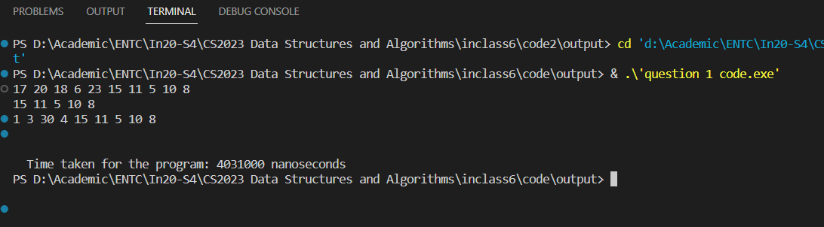

**( Question 2 ) Expected output:**

**( Question 3 ) Comparison:**

Time taken to Execute the Stack implementation using Array: 4031000 ns.

Time taken to Execute the Stack implementation using LinkedList: 4049000 ns.

We can see, Time taken to Execute the Stack implementation using LinkedList is slightly greater than the Time taken to Execute the Stack implementation using Array for these given operations.